Example of use of the Agreement Realization Operator
Supplemental KPML documentation: May 2000
(supersedes previous version of: Feb99)
John Bateman, Bremen

This is a brief example of the kinds of agreement supported by KPML as of May 2000. In order to use the examples here, it is necessary for KPML 3.2 or above to be installed.

The ability to ‘move’ features around a syntactic tree is a basic representational resource that is used in many linguistic frameworks. Most modern frameworks choose to do this in terms of feature sharing enforced by unification. Since KPML does not employ unification this option is not available to writers of grammars within the KPML framework. But for many languages, not being able to concisely express feature sharing complicates a description considerably. To ease this difficulty, KPML provides the ‘agreement’ realization operator: this allows groups of grammatical features to be selected together conditionally. Thus, instead of saying that two slots in a unification grammar share values, for a KPML grammar we write that the choices for the features of those slots are linked—when one value is chosen for one, then another specified value is selected for the other. This does not require unification, thereby avoiding the performance losses that unification brings, but still provides a concise way of stating feature co-occurrence constraints.

Definitions
The agreement operator is typically used to enforce ‘agreement’ between grammatical constituents: e.g., to state that the finite verb will take an appropriate number feature depending on the number feature selected within the Subject grammatical constituent. The choice then needs to be made only once—typically while constructing the grammatical unit for the Subject—and the Finite element is then made to conform. Within the systemic literature, the kind of phenomena that the agreement operator is targeting is that of ‘prosodies’ in the Firthian sense; i.e., not restricted to phonology. A prosody is a linguistic domain over which selections of some specified features pattern together—i.e., are co-constrained.
There are several distinct kinds of interdependencies between feature selection that are supported by the agreement operator. These may be divided into sibling-dependencies and child-dependencies. They can best be illustrated graphically.

Sibling-dependencies
The following graph shows the usual state of affairs that should be covered with the agreement constraint.
When an agreement constraint is triggered in some constituent—i.e., in the traversal of the system network that is creating the substructure for that constituent—then a set of dependencies are established across children of that constituent. In the diagram, constraints are established across the constituents labelled a,b and c. The constituent b is the independent constituent, while constituents a and c are dependent constituents. No action occurs until these subconstituents are themselves been generated: i.e., their internal structure is being created by means of a traversal of the network. Then, if in the network traversal responsible for Constituent b, the feature f_{b} is selected, then the corresponding features f_{a} and f_{c} are added to the preselection of their respective constituents, i.e., constituents a and c. The same applies to the features g, h, etc. as suggested in the diagram. The generation algorithm then also ensures that the independent constituents within some rank are generated before dependent constituents. Since the interdependencies that are defined to hold do so across siblings, i.e., immediate subconstituents of some constituent, this type of agreement is referred to as creating sibling-dependencies.

Child-dependencies
The second type of dependencies that can be created using the agreement operator is depicted in the following diagram.
In this case, the dependency is not between features that are selected in the subconstituents of the unit where the agreement operator occurs, but between further features from that same cycle through the grammar. That is, if the agreement constraint has been selected, then a conditional preselection is set up between some set of features within that cycle and further immediate subconstituents. Since the dependencies are in this case between a constituent and its children, the agreement is labelled child-agreement.
This is very similar to the normal state of affairs with preselection. The difference is in the fact that (a) multiple conditional preselections can be established within a single realization statement and, more importantly, (b) that the preselection only takes effect if the concerned constituent is actually inserted into structure. The preselection is therefore a potential preselection: if the mentioned constituent is not inserted into structure, then there is no affect. This therefore permits grammar writers to state co-constraints on feature occurrence without requiring that they also restrict those constraints to apply in just those cases where a constituent is inserted.

Examples of use
Two examples of use of the agreement operator are provided. Each example takes the form of a small toy grammar that contains several occurrences of the agreement behaviour introduced above. The first example is concerned with sibling agreement, the second with child agreement. Each resource should be loaded into KPML in the normal manner (i.e., by placing the resource in a resource directory, setting resource loading mode to multilingual and selecting the resource for loading). The resources are called AGREEMENT-EG1 and AGREEMENT-EG2. Neither corresponds to the agreement behaviour of any particular language, but combines aspects of several.

AGREEMENT-EG1
After loading, the grammar of the first example can be graphed and looks as follows.

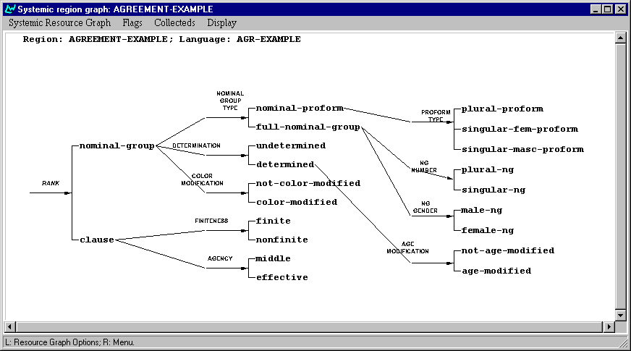

There are two ranks, clauses and nominal groups. Clauses are very simple, they may be either finite or nonfinite, and either middle or effective. All clauses have a Subject, Process and Medium. Effective clauses have additionally a DirectObject that conflates with the Medium. To make for some more interesting agreement patterns, when a clause is finite its Subject and Process agree in number and gender. Number and gender are determined by the Subject; however, when a clause is nonfinite then it is the clause’s Medium with which the Process agrees (also in number and gender). This is simply to show that the domains over which the agreement is set up to operate are completely arbitrary and can apply to any grammatical functions inserted into structure.

The realization statements for these different agreement patterns are contained in the system FINITENESS and can be seen on the next page.

The finite feature sets up an agreement between the Subject and the Finite element, and then lists the correspondences between feature selections in the Subject and those in the Finite. Thus, when, for example, `plural-ng’ is selected in the Subject, then the Finite is automatically also constrained to have a `classify plural-vg’ apply to it. Similarly in the nonfinite-case: here ther agreement is between the medium and the Nonfinite, with similar agreement constraints applying.

This toy resource has no semantics defined for it, and hence we can only generate by traversing the grammar by hand. Traversal can be started by using the `Traverse Grammar’ option in the Development window (i.e., not by `Generate Sentence’ because there are no semantics to generate from).

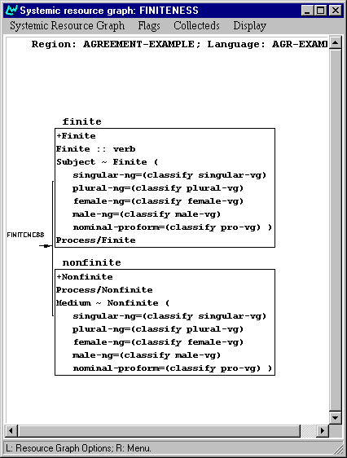

Lets do this to examine some simple clause structures. If we select `clause’, `finite’ and `middle’, then we have the simplest clause structure possible for this grammar, with only one participant (the Subject). After selecting these three features, the traversal will want to continue to generate the Subject. If we abort the generation before doing this, and inspect the structure that has been generated so far, it looks like this:

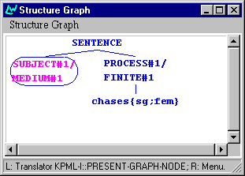

This shows that the clause has just two constituents, it was about to generate the Subject/Medium when we aborted generation, and it has already lexified Process/Finite to be the word `chases{sg;fem}’. This is meant to indicate that we have the word `chase’ but constrained to be singular and feminine. Since we did not generate the Subject, it could not enforce agreement and so this lexical choice has been made at random.

Now lets do the same again, but go on to generate the Subject as a singular masculine nominal group without any modification. So we Traverse Grammar again and continue with the feature selections: `not-color-modified’, `undetermined’, `full-nominal-group’, `male-ng’ and `singular-ng’. This then generates the string:

John chases{sg;masc}

If we do the same, but this time select `female-ng’, then we obtain the string:

Mary chases{sg;fem}

Note that no additional selections for the constraints on the Finite/Process were required. The corresponding strings with `plural-ng’ selected are:

Bob and Harry chase{pl;masc}
Mary and Jane chase{pl;fem}

Note that when we graph these structures, we do not see the additional constraints that were imposed by agreement. The structure graph just shows the features as classifed and inflectified in the grammar without the agreement operator:

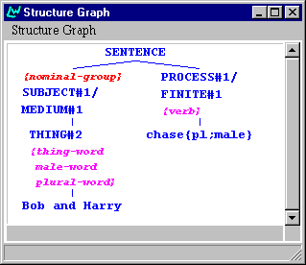

The particular selection of lexical items is being driven entirely in these examples by the classify realization statements that are set rather than by any semantics. Agreement in the non-finite cases operates similarly, but between Medium and Process rather than between Subject and Process as here. When the clause is `middle’ these cases will of course be the same.

In this most basic case of agreement, the operation is as follows. The agreement operator establishes a conditioning constituent (here the Subject) and a conditioned constituent. When a conditioning constituent has been generated, its selection expression is examined to see if any of the features effected by an agreement declaration have been selected. If they have been, then the corresponding conditioned features are added to the preselections of the conditioned constituent. Thus, looking at the selection expression in the present case, we see the following:

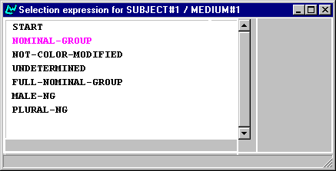

Referring back to the agreement operator, we can see that there are two features here that are mentioned: the `male-ng’ and the `plural-ng’. This triggers the corresponding features `male-vg’ and `plural-vg’ to be used to classify (since this is what the agreement operator in the FINITENESS system says) the Process. It is also, of course, possible here to just state that a feature should preselect the conditioned constituent as described in the original documentation (hardcopy 1.0).

The behaviour of agreement we illustrate here within the nominal group is more complex. Here this toy grammar enforces agreement between the head of the nominal group (the Thing) and modifiers of age and colour, as well as the determiner. Therefore in a nominal group that has all of these properties, there will be agreement running through most of the constituents present. Some examples of `full-nominal-groups’ are the following (the determiners are realized using some pseudo French/Spanish for variation):

Le old{masc} John red{masc}
La old{fem} Mary red{fem}
Les old{masc} Bob and Harry red{masc}
Les old{fem} Mary and Jane red{fem}

Here we can see that the age and colour are only expressing agreement in terms of gender, while the determiner also expresses agreement with number. The pronominal nominal groups show similar patterns, e.g.:
La old{fem} elle red{fem}

These are included like this to show another technically different type of agreement in operation: the previous example was enforcing agreement when the Thing was classified, here we see agreement also being enforced when the Thing is inflectified to give the correct form. We can see this by comparing the detailed structure graphs for the two cases:

Classify:

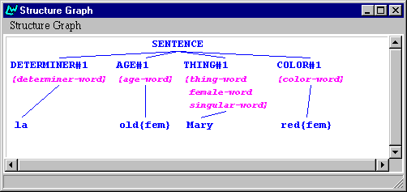

Inflectify:

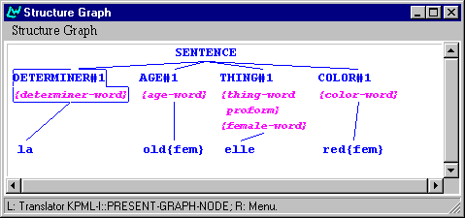

The feature that causes agreement is `female-word’ in both cases. But in the first case it is classified, and in the second case inflectified (as indicated by its appearance in the second set of curly brackets after Thing). This treatment is not recommended, it is simply to show that both classify and inflectify features can serve as the conditioning environment for an agreement. Note that both these cases are different to the first example above, where the conditioning constituent had a full grammar traversal of its own.

While these technical differences should not make too much difference during grammar writing, it is probably useful to know that there are such differences in case of problems with debugging the resources.

Finally, here is the grammar network for the nominal group, showing the realizations containing agreement operators. Note here the illustratory use of classifies for the color modification in contrast to the inflectifies of the age modification. Again, this is not motivated from any data, just to show different treatments. Also, in order that the lexical selections here work as shown, there is a rudimentary inflection method defined for the language variety: this is contained in the Lexicons directory of AGR-EXAMPLE.
Appendix 1 contains a listing of many of the possible phrases that this grammar generates.

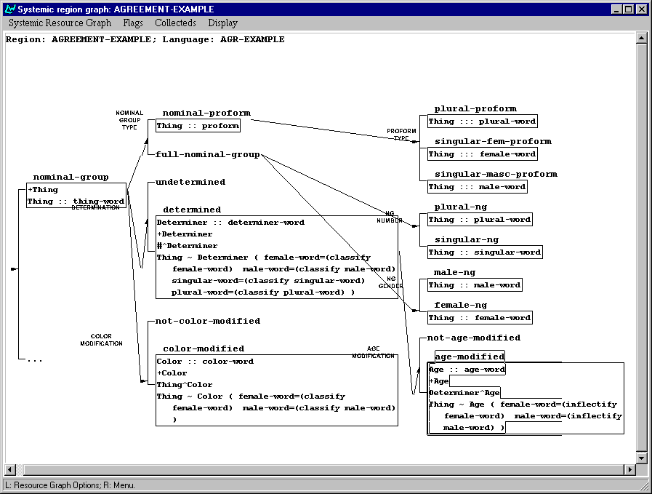

AGREEMENT-EG2
The second example provides examples of both types of agreement—i.e., both sibling and child—as well as providing a small semantics in order to allow generation from SPL input specifications. These provide examples also of obtaining information from the lexicon (e.g., lexical gender). The language variety for the second example is called simply AGREEMENT. You should set this as the current language when exploring it.

After loading, the example grammar AGREEMENT-EG2 looks as shown in the following two graphs. The networks as shown separate the grammar into the word rank systems and the rest
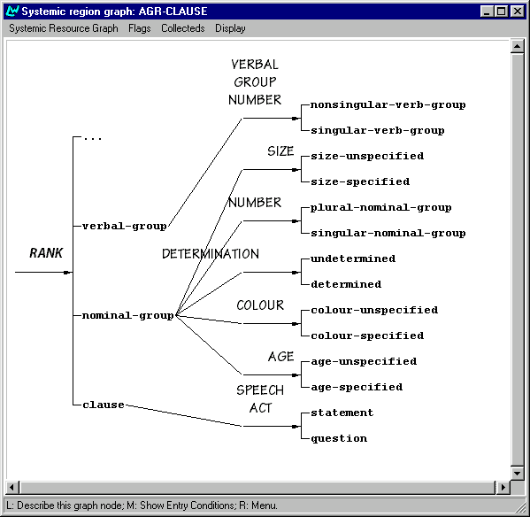

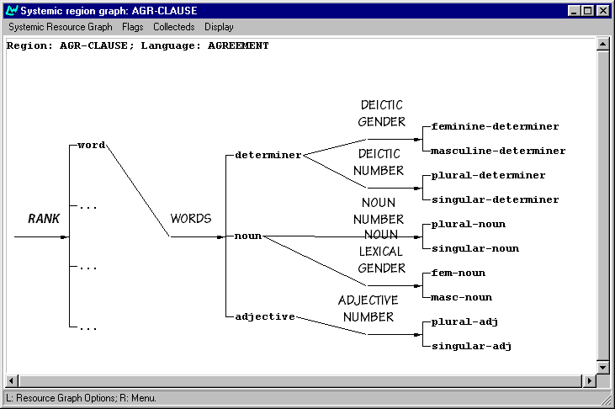

Agreement work is done both at the clause rank and at the nominal group rank. The clause rank agreement is another example of sibling agreement as used in the first agreement example; it simply enforces number agreement between Subject and Finite. The nominal group agreement constraints are more complex. The realization statements for the feature nominal-group are as follows.
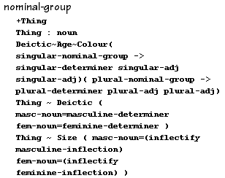
There are three sets of agreement constraints:
- two cases of sibling agreement across Thing and Deictic and across Thing and Size; these both handle agreement in lexical gender. The Deictic and Size are constrained so that they show the same lexical gender as the head of the nominal group: the Thing. They differ in that that lexical gender is controlled by a further traversal of the grammar for the Deictic constituent (at word rank), whereas the Size constituent is directly generated via lexical selection and morphological inflection.
- one case of child agreement that conditions choices in the constituents Deictic, Age and Colour to be dependent on selections made during the traversal of the network that is generating the parent nominal group. This agreement enforces singular and plural selections across the three constituents depending on whether the nominal group as a whole has been determined to be singular or plural.
The resource file definition format for the child agreement case is as follows:
(AGREEMENT (DEICTIC AGE COLOUR)
(SINGULAR-NOMINAL-GROUP SINGULAR-DETERMINER
SINGULAR-ADJ
SINGULAR-ADJ)
(PLURAL-NOMINAL-GROUP
PLURAL-DETERMINER
PLURAL-ADJ
PLURAL-ADJ))
This states that should the feature singular-nominal-group be selected in the current traversal cycle—i.e., in the same cycle that the agreement constraint is triggered—then the feature singular-determiner will be added to the constraints for the Deictic subconstituent, and the feature singular-adj will be added to the constraints for the constituents Age and Colour. If any or all of these constituents are not inserted into the current nominal group, then the agreement constraint has no effect. Similarly for the plural case.
This provides a ready means of ensuring basic standard behaviour for a grammatical unit without the need to make statements exactly dependent on whether some constituent has been inserted into structure or not. The should therefore be used for features traditionally considered to be ‘head’ features: i.e., features that are really to do with the basics of structure construction (typically part of the logical metafunction) rather than meaningful choices.
As mentioned, the AGREEMENT-EG2 resource includes a semantic specification and so includes SPL examples illustrating the coverage and behaviour of the resource. These should be loaded in the usual manner—e.g., from the example manager. The first of this example set generates as follows.

Name: AGR-1
Target: Det{masc;sing} dog{masc;singular} chases{singular} cat{fem;singular}
Generated: Det{masc;sing} dog{masc;singular} chases{singular} cat{fem;singular}

(EXAMPLE
:NAME AGR-1
:LOGICALFORM
(S / PROCESS
:LEX CHASE
:SPEECH-ACT-ID (SA / ASSERTION )
:ACTOR
(S2 / OBJECT
:LEX DOG
:IDENTIFIABILITY-Q IDENTIFIABLE )

:ACTEE
(S3 / OBJECT
:LEX CAT )
)
)
This shows the agreement constraints in operation. It can be seen that the input specification includes only the identifiability of the participants and (in this case by default) the number information (singular vs. plural). The distribution of this information around the constituents of the clause, as well as the recognition of lexical gender, is enforced by the grammar.
A more complex generated example is the following (AGR-5):

Det{fem;sing} big{fem} old{sing} red{sing} cat{fem;singular} chases{singular} big{masc} old{sing} dog{masc;singular}

This shows the diverse distribution of information: number across Age and Colour, lexical gender across Size, both lexical gender and number across the Deictic, etc. The structural representation of the first two constituents of this generated sentence, complete with the various agreement dependencies annotated can be shown as follows.

A listing of the possible constructions that can be generated with this grammar is shown in Appendix II.

APPENDIX 1: Examples of nominal groups generated with the toy grammar AGREEMENT-EG1

Fixed features: (NOMINAL-GROUP FULL-NOMINAL-GROUP)

(PLURAL-NG MALE-NG UNDETERMINED NOT-COLOR-MODIFIED):
Bob and Harry
(SINGULAR-NG MALE-NG UNDETERMINED NOT-COLOR-MODIFIED):
John
(PLURAL-NG FEMALE-NG UNDETERMINED NOT-COLOR-MODIFIED):
Mary and Jane
(SINGULAR-NG FEMALE-NG UNDETERMINED NOT-COLOR-MODIFIED):
Mary
(PLURAL-NG MALE-NG DETERMINED NOT-COLOR-MODIFIED):
Les old{masc} Bob and Harry
(SINGULAR-NG MALE-NG DETERMINED NOT-COLOR-MODIFIED):
Le old{masc} John
(PLURAL-NG FEMALE-NG DETERMINED NOT-COLOR-MODIFIED):
Les old{fem} Mary and Jane
(SINGULAR-NG FEMALE-NG DETERMINED NOT-COLOR-MODIFIED):
La old{fem} Mary
(PLURAL-NG MALE-NG UNDETERMINED COLOR-MODIFIED):
Bob and Harry red{masc}
(SINGULAR-NG MALE-NG UNDETERMINED COLOR-MODIFIED):
John red{masc}
(PLURAL-NG FEMALE-NG UNDETERMINED COLOR-MODIFIED):
Mary and Jane red{fem}
(SINGULAR-NG FEMALE-NG UNDETERMINED COLOR-MODIFIED):
Mary red{fem}
(PLURAL-NG MALE-NG DETERMINED COLOR-MODIFIED):
Les old{masc} Bob and Harry red{masc}
(SINGULAR-NG MALE-NG DETERMINED COLOR-MODIFIED):
Le old{masc} John red{masc}
(PLURAL-NG FEMALE-NG DETERMINED COLOR-MODIFIED):
Les old{fem} Mary and Jane red{fem}
(SINGULAR-NG FEMALE-NG DETERMINED COLOR-MODIFIED):
La old{fem} Mary red{fem}

fixed: (NOMINAL-GROUP FULL-NOMINAL-GROUP DETERMINED)

(PLURAL-NG MALE-NG NOT-AGE-MODIFIED NOT-COLOR-MODIFIED):
Les Bob and Harry
(SINGULAR-NG MALE-NG NOT-AGE-MODIFIED NOT-COLOR-MODIFIED):
Le John
(PLURAL-NG FEMALE-NG NOT-AGE-MODIFIED NOT-COLOR-MODIFIED):
Les Mary and Jane
(SINGULAR-NG FEMALE-NG NOT-AGE-MODIFIED NOT-COLOR-MODIFIED):
La Mary
(PLURAL-NG MALE-NG AGE-MODIFIED NOT-COLOR-MODIFIED):
Les old{masc} Bob and Harry
(SINGULAR-NG MALE-NG AGE-MODIFIED NOT-COLOR-MODIFIED):
Le old{masc} John
(PLURAL-NG FEMALE-NG AGE-MODIFIED NOT-COLOR-MODIFIED):
Les old{fem} Mary and Jane
(SINGULAR-NG FEMALE-NG AGE-MODIFIED NOT-COLOR-MODIFIED):
La old{fem} Mary
(PLURAL-NG MALE-NG NOT-AGE-MODIFIED COLOR-MODIFIED):
Les Bob and Harry red{masc}
(SINGULAR-NG MALE-NG NOT-AGE-MODIFIED COLOR-MODIFIED):
Le John red{masc}
(PLURAL-NG FEMALE-NG NOT-AGE-MODIFIED COLOR-MODIFIED):
Les Mary and Jane red{fem}
(SINGULAR-NG FEMALE-NG NOT-AGE-MODIFIED COLOR-MODIFIED):
La Mary red{fem}
(PLURAL-NG MALE-NG AGE-MODIFIED COLOR-MODIFIED):
Les old{masc} Bob and Harry red{masc}
(SINGULAR-NG MALE-NG AGE-MODIFIED COLOR-MODIFIED):
Le old{masc} John red{masc}
(PLURAL-NG FEMALE-NG AGE-MODIFIED COLOR-MODIFIED):
Les old{fem} Mary and Jane red{fem}
(SINGULAR-NG FEMALE-NG AGE-MODIFIED COLOR-MODIFIED):
La old{fem} Mary red{fem}

features fixed: (NOMINAL-GROUP NOMINAL-PROFORM DETERMINED)

(not-color-modified not-age-modified plural-proform):
Les ils
(color-modified not-age-modified plural-proform):
Les ils red{fem}
(not-color-modified age-modified plural-proform):
Les old ils
(color-modified age-modified plural-proform):
Les old ils red{fem}
(not-color-modified not-age-modified singular-fem-proform):
La elle
(color-modified not-age-modified singular-fem-proform):
La elle red{fem}
(not-color-modified age-modified singular-fem-proform):
La old{fem} elle
(color-modified age-modified singular-fem-proform):
La old{fem} elle red{fem}
(not-color-modified not-age-modified singular-masc-proform):
Le il
(color-modified not-age-modified singular-masc-proform):
Le il red{masc}
(not-color-modified age-modified singular-masc-proform):
Le old{masc} il
(color-modified age-modified singular-masc-proform):
Le old{masc} il red{masc}

features fixed: (NOMINAL-GROUP NOMINAL-PROFORM UNDETERMINED)

(not-color-modified plural-proform):
Ils
(color-modified plural-proform):
Ils red{fem}
(not-color-modified singular-fem-proform):
Elle
(color-modified singular-fem-proform):
Elle red{fem}
(not-color-modified singular-masc-proform):
Il
(color-modified singular-masc-proform):
Il red{masc}

APPENDIX II: Examples of nominal groups generated with the toy grammar AGREEMENT-EG2

The following examples can be generated by calling the function (agreement-tester) from a Lisp Listener. This could also be used as a more extensive set of examples for testing during maintenance and development.

[1 ] "Det{fem;plural} big{fem} old{plural} red{plural} cats{fem;plural} chase{plural} dog{masc;singular} "
[2 ] "Det{masc;plural} big{masc} old{plural} red{plural} dogs{masc;plural} chase{plural} dog{masc;singular} "
[3 ] "Big{fem} old{plural} red{plural} cats{fem;plural} chase{plural} dog{masc;singular} "
[4 ] "Big{masc} old{plural} red{plural} dogs{masc;plural} chase{plural} dog{masc;singular} "
[5 ] "Det{fem;plural} big{fem} red{plural} cats{fem;plural} chase{plural} dog{masc;singular} "
[6 ] "Det{masc;plural} big{masc} red{plural} dogs{masc;plural} chase{plural} dog{masc;singular} "
[7 ] "Big{fem} red{plural} cats{fem;plural} chase{plural} dog{masc;singular} "
[8 ] "Big{masc} red{plural} dogs{masc;plural} chase{plural} dog{masc;singular} "
[9 ] "Det{fem;plural} big{fem} old{plural} cats{fem;plural} chase{plural} dog{masc;singular} "
[10 ] "Det{masc;plural} big{masc} old{plural} dogs{masc;plural} chase{plural} dog{masc;singular} "
[11 ] "Big{fem} old{plural} cats{fem;plural} chase{plural} dog{masc;singular} "
[12 ] "Big{masc} old{plural} dogs{masc;plural} chase{plural} dog{masc;singular} "
[13 ] "Det{fem;plural} big{fem} cats{fem;plural} chase{plural} dog{masc;singular} "
[14 ] "Det{masc;plural} big{masc} dogs{masc;plural} chase{plural} dog{masc;singular} "
[15 ] "Big{fem} cats{fem;plural} chase{plural} dog{masc;singular} "
[16 ] "Big{masc} dogs{masc;plural} chase{plural} dog{masc;singular} "
[17 ] "Det{fem;plural} old{plural} red{plural} cats{fem;plural} chase{plural} dog{masc;singular} "
[18 ] "Det{masc;plural} old{plural} red{plural} dogs{masc;plural} chase{plural} dog{masc;singular} "
[19 ] "Old{plural} red{plural} cats{fem;plural} chase{plural} dog{masc;singular} "
[20 ] "Old{plural} red{plural} dogs{masc;plural} chase{plural} dog{masc;singular} "
[21 ] "Det{fem;plural} red{plural} cats{fem;plural} chase{plural} dog{masc;singular} "
[22 ] "Det{masc;plural} red{plural} dogs{masc;plural} chase{plural} dog{masc;singular} "
[23 ] "Red{plural} cats{fem;plural} chase{plural} dog{masc;singular} "
[24 ] "Red{plural} dogs{masc;plural} chase{plural} dog{masc;singular} "
[25 ] "Det{fem;plural} old{plural} cats{fem;plural} chase{plural} dog{masc;singular} "
[26 ] "Det{masc;plural} old{plural} dogs{masc;plural} chase{plural} dog{masc;singular} "
[27 ] "Old{plural} cats{fem;plural} chase{plural} dog{masc;singular} "
[28 ] "Old{plural} dogs{masc;plural} chase{plural} dog{masc;singular} "
[29 ] "Det{fem;plural} cats{fem;plural} chase{plural} dog{masc;singular} "
[30 ] "Det{masc;plural} dogs{masc;plural} chase{plural} dog{masc;singular} "
[31 ] "Cats{fem;plural} chase{plural} dog{masc;singular} "
[32 ] "Dogs{masc;plural} chase{plural} dog{masc;singular} "
[33 ] "Det{fem;sing} big{fem} old{sing} red{sing} cat{fem;singular} chases{singular} dog{masc;singular} "
[34 ] "Det{masc;sing} big{masc} old{sing} red{sing} dog{masc;singular} chases{singular} dog{masc;singular} "
[35 ] "Big{fem} old{sing} red{sing} cat{fem;singular} chases{singular} dog{masc;singular} "
[36 ] "Big{masc} old{sing} red{sing} dog{masc;singular} chases{singular} dog{masc;singular} "
[37 ] "Det{fem;sing} big{fem} red{sing} cat{fem;singular} chases{singular} dog{masc;singular} "
[38 ] "Det{masc;sing} big{masc} red{sing} dog{masc;singular} chases{singular} dog{masc;singular} "
[39 ] "Big{fem} red{sing} cat{fem;singular} chases{singular} dog{masc;singular} "
[40 ] "Big{masc} red{sing} dog{masc;singular} chases{singular} dog{masc;singular} "
[41 ] "Det{fem;sing} big{fem} old{sing} cat{fem;singular} chases{singular} dog{masc;singular} "
[42 ] "Det{masc;sing} big{masc} old{sing} dog{masc;singular} chases{singular} dog{masc;singular} "
[43 ] "Big{fem} old{sing} cat{fem;singular} chases{singular} dog{masc;singular} "
[44 ] "Big{masc} old{sing} dog{masc;singular} chases{singular} dog{masc;singular} "
[45 ] "Det{fem;sing} big{fem} cat{fem;singular} chases{singular} dog{masc;singular} "
[46 ] "Det{masc;sing} big{masc} dog{masc;singular} chases{singular} dog{masc;singular} "
[47 ] "Big{fem} cat{fem;singular} chases{singular} dog{masc;singular} "
[48 ] "Big{masc} dog{masc;singular} chases{singular} dog{masc;singular} "
[49 ] "Det{fem;sing} old{sing} red{sing} cat{fem;singular} chases{singular} dog{masc;singular} "
[50 ] "Det{masc;sing} old{sing} red{sing} dog{masc;singular} chases{singular} dog{masc;singular} "
[51 ] "Old{sing} red{sing} cat{fem;singular} chases{singular} dog{masc;singular} "
[52 ] "Old{sing} red{sing} dog{masc;singular} chases{singular} dog{masc;singular} "
[53 ] "Det{fem;sing} red{sing} cat{fem;singular} chases{singular} dog{masc;singular} "
[54 ] "Det{masc;sing} red{sing} dog{masc;singular} chases{singular} dog{masc;singular} "
[55 ] "Red{sing} cat{fem;singular} chases{singular} dog{masc;singular} "
[56 ] "Red{sing} dog{masc;singular} chases{singular} dog{masc;singular} "
[57 ] "Det{fem;sing} old{sing} cat{fem;singular} chases{singular} dog{masc;singular} "
[58 ] "Det{masc;sing} old{sing} dog{masc;singular} chases{singular} dog{masc;singular} "
[59 ] "Old{sing} cat{fem;singular} chases{singular} dog{masc;singular} "
[60 ] "Old{sing} dog{masc;singular} chases{singular} dog{masc;singular} "
[61 ] "Det{fem;sing} cat{fem;singular} chases{singular} dog{masc;singular} "
[62 ] "Det{masc;sing} dog{masc;singular} chases{singular} dog{masc;singular} "
[63 ] "Cat{fem;singular} chases{singular} dog{masc;singular} "
[64 ] "Dog{masc;singular} chases{singular} dog{masc;singular} "
[65 ] "Chase{plural} det{fem;plural} big{fem} old{plural} red{plural} cats{fem;plural} dog{masc;singular} "
[66 ] "Chase{plural} det{masc;plural} big{masc} old{plural} red{plural} dogs{masc;plural} dog{masc;singular} "
[67 ] "Chase{plural} big{fem} old{plural} red{plural} cats{fem;plural} dog{masc;singular} "
[68 ] "Chase{plural} big{masc} old{plural} red{plural} dogs{masc;plural} dog{masc;singular} "
[69 ] "Chase{plural} det{fem;plural} big{fem} red{plural} cats{fem;plural} dog{masc;singular} "
[70 ] "Chase{plural} det{masc;plural} big{masc} red{plural} dogs{masc;plural} dog{masc;singular} "
[71 ] "Chase{plural} big{fem} red{plural} cats{fem;plural} dog{masc;singular} "
[72 ] "Chase{plural} big{masc} red{plural} dogs{masc;plural} dog{masc;singular} "
[73 ] "Chase{plural} det{fem;plural} big{fem} old{plural} cats{fem;plural} dog{masc;singular} "
[74 ] "Chase{plural} det{masc;plural} big{masc} old{plural} dogs{masc;plural} dog{masc;singular} "
[75 ] "Chase{plural} big{fem} old{plural} cats{fem;plural} dog{masc;singular} "
[76 ] "Chase{plural} big{masc} old{plural} dogs{masc;plural} dog{masc;singular} "
[77 ] "Chase{plural} det{fem;plural} big{fem} cats{fem;plural} dog{masc;singular} "
[78 ] "Chase{plural} det{masc;plural} big{masc} dogs{masc;plural} dog{masc;singular} "
[79 ] "Chase{plural} big{fem} cats{fem;plural} dog{masc;singular} "
[80 ] "Chase{plural} big{masc} dogs{masc;plural} dog{masc;singular} "
[81 ] "Chase{plural} det{fem;plural} old{plural} red{plural} cats{fem;plural} dog{masc;singular} "
[82 ] "Chase{plural} det{masc;plural} old{plural} red{plural} dogs{masc;plural} dog{masc;singular} "
[83 ] "Chase{plural} old{plural} red{plural} cats{fem;plural} dog{masc;singular} "
[84 ] "Chase{plural} old{plural} red{plural} dogs{masc;plural} dog{masc;singular} "
[85 ] "Chase{plural} det{fem;plural} red{plural} cats{fem;plural} dog{masc;singular} "
[86 ] "Chase{plural} det{masc;plural} red{plural} dogs{masc;plural} dog{masc;singular} "
[87 ] "Chase{plural} red{plural} cats{fem;plural} dog{masc;singular} "
[88 ] "Chase{plural} red{plural} dogs{masc;plural} dog{masc;singular} "
[89 ] "Chase{plural} det{fem;plural} old{plural} cats{fem;plural} dog{masc;singular} "
[90 ] "Chase{plural} det{masc;plural} old{plural} dogs{masc;plural} dog{masc;singular} "
[91 ] "Chase{plural} old{plural} cats{fem;plural} dog{masc;singular} "
[92 ] "Chase{plural} old{plural} dogs{masc;plural} dog{masc;singular} "
[93 ] "Chase{plural} det{fem;plural} cats{fem;plural} dog{masc;singular} "
[94 ] "Chase{plural} det{masc;plural} dogs{masc;plural} dog{masc;singular} "
[95 ] "Chase{plural} cats{fem;plural} dog{masc;singular} "
[96 ] "Chase{plural} dogs{masc;plural} dog{masc;singular} "
[97 ] "Chases{singular} det{fem;sing} big{fem} old{sing} red{sing} cat{fem;singular} dog{masc;singular} "
[98 ] "Chases{singular} det{masc;sing} big{masc} old{sing} red{sing} dog{masc;singular} dog{masc;singular} "
[99 ] "Chases{singular} big{fem} old{sing} red{sing} cat{fem;singular} dog{masc;singular} "
[100] "Chases{singular} big{masc} old{sing} red{sing} dog{masc;singular} dog{masc;singular} "
[101] "Chases{singular} det{fem;sing} big{fem} red{sing} cat{fem;singular} dog{masc;singular} "
[102] "Chases{singular} det{masc;sing} big{masc} red{sing} dog{masc;singular} dog{masc;singular} "
[103] "Chases{singular} big{fem} red{sing} cat{fem;singular} dog{masc;singular} "
[104] "Chases{singular} big{masc} red{sing} dog{masc;singular} dog{masc;singular} "
[105] "Chases{singular} det{fem;sing} big{fem} old{sing} cat{fem;singular} dog{masc;singular} "
[106] "Chases{singular} det{masc;sing} big{masc} old{sing} dog{masc;singular} dog{masc;singular} "
[107] "Chases{singular} big{fem} old{sing} cat{fem;singular} dog{masc;singular} "
[108] "Chases{singular} big{masc} old{sing} dog{masc;singular} dog{masc;singular} "
[109] "Chases{singular} det{fem;sing} big{fem} cat{fem;singular} dog{masc;singular} "
[110] "Chases{singular} det{masc;sing} big{masc} dog{masc;singular} dog{masc;singular} "
[111] "Chases{singular} big{fem} cat{fem;singular} dog{masc;singular} "
[112] "Chases{singular} big{masc} dog{masc;singular} dog{masc;singular} "
[113] "Chases{singular} det{fem;sing} old{sing} red{sing} cat{fem;singular} dog{masc;singular} "
[114] "Chases{singular} det{masc;sing} old{sing} red{sing} dog{masc;singular} dog{masc;singular} "
[115] "Chases{singular} old{sing} red{sing} cat{fem;singular} dog{masc;singular} "
[116] "Chases{singular} old{sing} red{sing} dog{masc;singular} dog{masc;singular} "
[117] "Chases{singular} det{fem;sing} red{sing} cat{fem;singular} dog{masc;singular} "
[118] "Chases{singular} det{masc;sing} red{sing} dog{masc;singular} dog{masc;singular} "
[119] "Chases{singular} red{sing} cat{fem;singular} dog{masc;singular} "
[120] "Chases{singular} red{sing} dog{masc;singular} dog{masc;singular} "
[121] "Chases{singular} det{fem;sing} old{sing} cat{fem;singular} dog{masc;singular} "
[122] "Chases{singular} det{masc;sing} old{sing} dog{masc;singular} dog{masc;singular} "
[123] "Chases{singular} old{sing} cat{fem;singular} dog{masc;singular} "
[124] "Chases{singular} old{sing} dog{masc;singular} dog{masc;singular} "
[125] "Chases{singular} det{fem;sing} cat{fem;singular} dog{masc;singular} "
[126] "Chases{singular} det{masc;sing} dog{masc;singular} dog{masc;singular} "
[127] "Chases{singular} cat{fem;singular} dog{masc;singular} "
[128] "Chases{singular} dog{masc;singular} dog{masc;singular} "

This is equivalent to issuing something like (say ‘(um / um-thing)) from a Lisp listener directly.

