JUAN RAFAEL ZAMARONO MANSILLA: BERICHT, 2. JAHR
Doktorandenstipendium: FNK-Nr. 10/115/9; Betreuer: Prof. Dr. John A. Bateman (FB10)

PART ONE: MONTH 13-18

Overview
According to the original plan included in the proposal for this research project, the period between the 13th and 18th month would be devoted to the preparation of materials and activities that would be used in tests with real students. Of course, the form of the materials and activities designed depends on what application of KPML we want to test. In the first report submitted after the first 12 months of research, five possible applications of generators in language teaching were suggested:
- the use of generators to provide grammar exercises at or below sentence level
- the use of generators as a tool for improving writing skills (divided into basic and advanced)
- the use of generators in ways similar to corpora
- the use of generators as tools for working with long texts
- the use of generators as tools for grammatical analysis
The materials developed so far roughly cover the first three applications: grammar exercises at or below sentence level, writing skills (basic only) and its use as a corpus.
Apart from the development materials, the past 6 months have also been spent developing something that had not been foreseen in the original proposal and whose necessity was expressed in the previous report: a special tool that will allow non-expert users to create grammar exercises automatically out of sentences loaded in the program. This tool, which can work in cooperation with KPML or independently, has been named Exercise Manager and is currently in progress. In this report I briefly describe the main features of a trial version of the tool that does not include all the commands and instructions the final product will have.

The development of materials
The materials developed for the tests with real students consist of a collection of sentences in English and Spanish that are generated with KPML and can be manipulated in different ways by the Exercise Manager to provide exercises of different types. They include over 50 sentences containing examples of the English prepositions at, in and on, over 200 sentences in Spanish covering various regions of the grammar (such as tense, aspect, pronouns, determination, quantification, etc) and over 50 sentences exemplifying the contrast in usage between the Spanish verbs ser and estar.
The creation of these sentences was more time-consuming than had been expected, mainly because of two factors. The first factor has to do with the way generators work. Generating a sentence usually requires the specification of input data; it is the combination of this input and the grammatical resources that gives a text in a natural language as a result. In the case of KPML the input is a semantic specification of the sentence based on systemic-functional theory. The following is the input required for the generation of the sentence This class of system is Smith's creation, isn't it?:

(EXAMPLE
:NAME EX-SET-14
:GENERATEDFORM "This class of system is Smith's creation, isn't it?"
:TARGETFORM "This class of system is Smith's creation, isn't it?"
:LOGICALFORM
(ASCR / CLASS-ASCRIPTION
:DOMAIN
(SYS1 / OBJECT :LEX SYSTEM :DETERMINER ZERO :ELEMENT-OF
(S / ORDERED-SET :LEX CLASS :NUMBER SINGULAR :DETERMINER THIS))
:RANGE
(CR / CREATIVE-MATERIAL-ACTION :LEX CREATION :OWNED-BY
(P / PERSON :NAME SMITH))
:CONFIRMATION-REQUEST-Q CONFIRMATIONREQUEST)
:SET-NAME |nigel-exerciseset|
)
This kind of input receives the name of SPL (sentence language plan), and as one can see from the example it does not take long to write. The problem is that it is not always easy to know what exact keywords must be used to refer to each process type or participant in the sentence. In my case I had to spend some time investigating this, most of the time looking into the program code. This undoubtedly slowed down the whole process of materials development, particularly in the beginning. On the other hand, an interesting by-product of my research is that there is now a reference guide available on the KPML website that lists the main keywords and commands used in KPML alongside their linguistic results. This guide will hopefully make the process of generation more accessible to non-expert users in future.
The second source of difficulty was pointed out in the first report: the linguistic resources of KPML are constantly being updated and expanded. Sometimes the problem I was faced with when generating a particular sentence was that the grammar of the language was simply not detailed enough to cope with a particular structure. As a matter of fact the design of materials has run parallel to the process of amelioration of linguistic resources. Particularly remarkable is the case of Spanish, which has moved from a state of basic development to a rather satisfactory degree of complexity in less than 18 months. Thus another interesting by-product of my research will be the production of better and more detailed computational grammars.

The Exercise Manager tool
An important issue put forward in the previous report was the necessity to create additional tools or components of KPML that would facilitate its use for language teaching and learning. In these six months we have produced a trial version of one of those tools, which we have called the Exercise Manager. Roughly speaking this component loads sentences generated with KPML and offers a menu with different options for the automatic creation of grammar exercises. As noted in the introduction, it is the result of the exploration of three potential applications of generators in language teaching: the use of generators to provide grammar exercises at or below sentence level, the use of generators as a tool for improving writing skills (basic) and the use of generators as a corpus. In the following sections I present briefly the research work that shaped the Exercise Manager. I conclude with a section where the main features of the trial version of the tool are described, bearing in mind that this is still at an early stage of development.

Grammar exercises at or below sentence level
In the previous report I described an experimental exploration of the possibilities generators offered in the creation of basic grammar exercises. I described how exercises taken from five English and Spanish language courses had been successfully computerized in KPML. Although there were interesting advantages to the KPML version of the activities, such as the possibility of using the sentences for multiple purposes, the possibility of altering the original sentences to vary the activity and the fact that KPML can generate the solution of activities that have been altered or created from scratch, an important difficulty remained: it was indispensable to have a certain degree of expertise for the creation or alteration of sentences.
To solve this difficulty we have designed the Exercise Manager, which saves the user all the trouble of working with the SPL’s. The program loads sentences generated with KPML and offers a menu with different options for the creation of activities. These options are the result of the inspection of about 30 courses of various languages (English, Spanish, French, German, Russian and Italian). Appendix A shows the references of these books. The purpose of the inspection was to establish abstract exercise types that occur recurrently in these books. Then we defined the algorithms that would automate the process by which activities corresponding to the types previously defined could be created from ordinary sentences. The following exercise types were found to be the most commonly used in language books:
- Multiple-choice. The student is presented with a sentence that contains a gap. This gap must be filled with one of various possibilities. KPML can prepare this type of activity by generating two, three, four or five alternatives to the word that is removed and displaying them together. The alternatives may be generated with no restrictions (that is, the program simply picks other lexical items from the lexicon that belong in the same word-class as the original item), semantic restrictions (the program picks lexical items that share semantic properties with the original word, such as motion preposition, material verb, mass noun, etc) or morphological restrictions (the program picks lexical items that share morphological properties with the original word, such as singular form, masculine form, dative form, etc). These restrictions are more or less relevant depending on the word-class of the item we wish to remove, and consequently not all restrictions will be available for all word-classes:
  - prepositions. With no restrictions or with semantic restrictions.
  - determiners. With no restrictions, with semantics restrictions or with morphological restrictions.
  - conjunctions. With no restrictions or with semantic restrictions.
  - verbs. With no restrictions, with semantics restrictions or with morphological restrictions.
  - adjectives. With no restrictions, with semantics restrictions or with morphological restrictions.
  - nouns. With no restrictions, with semantics restrictions or with morphological restrictions.
  - pronouns. With no restrictions or with morphological restrictions.
- Fill the gap with the right form of x. Here the student must fill a gap with the right form of the word suggested. KPML can prepare this type of exercise by removing the desired word and showing its base form, which is stored in the lexicon. This operation is of interest only for those word-classes that are inflected:
  - verbs
  - adjectives
  - determiners
  - nouns
  - pronouns
- Fill the gaps with the following words. Here the student receives a group of sentences with gaps that must be filled with words that are listed or shown in a box. KPML can prepare this type of exercise by removing the desired words and showing the items that have been removed in a box or a list. Again, the removed items may be chosen with word-class as the only restriction or with additional semantic restrictions (that is, the program only removes those words that contain certain semantic properties, such as motion preposition, extending conjunctions, personal pronouns, etc).
- Change the sentence properties. The student has to change a group of sentences according to one of the parameters listed below. This exercise type can be prepared by simply generating the sentences with the new values replacing the old ones.
  - Polarity (from positive to negative, etc)
  - Mood (from affirmative to interrogative, etc)
  - Number (from singular to plural, etc)
  - Voice (from active to passive, etc)
  - Tense (from present to past, etc)
In the current version of the Exercise Manager only the second and third points are available, being the other two in progress.
In the previous report I also emphasized one of KPML’s most outstanding features: the ability to give the solution to all exercises, even those that were created by the user. The solutions are generated by the program making use of its grammatical resources, which are then shown to the user to serve as a model of correction. But these grammatical resources could be used for something more interesting than just evaluating the user’s answer as right or wrong. The Exercise Manager will include two main levels of error analysis: typographic and grammatical.
The typographic level comprises problems such as spelling mistakes (including capitalization) and typos. To deal with these we will use routines described from very early in the history of CALL by previous authors (Higgins & Johns 1984, Kenning & Kenning 1984, Allen 1971). Even at this less complicated typographic level generators have the advantage that the users or the developers need not include the right spelling for each word, because they are already present in the lexicon files of the program.
The grammatical level comprises all the mistakes that result from an inaccurate use of the target language grammar. In CALL programs that incorporate error analysis and feedback it is unavoidable to elaborate a list of anticipated mistakes (Witton 1992, Pusack 1983, Underwood 1984, Hope et al. 1984, Boylan & Micarelli 1998). This list is intended to specify the most common mistakes students make, normally based on experience. The list also includes appropriate comments or hints to help the students correct themselves. With KPML this process could be automated to some extent through the use of the grammatical resources. The Exercise Manager will compare the user’s answer with the solution automatically generated. If there is a mismatch, the program will generate alternative solutions yielded by successive traversals of the grammar making different choices. If any of the alternative generations matches the user’s answer, the program could display a message with information provided by the features of the grammar that had to be chosen in order to match the student’s answer. For example, if the student types in the incorrect plural foots, the program will only be able to generate this form when choosing the feature s-plural in the grammar. This valuable information can then be used to return precise comments about the source of the mistake.
The routine I have just presented may not cover all possible mistakes produced by language students, but in my opinion it covers enough of them to ensure that a lot of time can be saved in the elaboration of lists of anticipated errors. At any rate the efficiency of this routine is an issue on which the tests with real students will shed some light.

Exercises to improve basic writing skills
In the first report I established a distinction between basic and advanced within the category of exercises to practise writing skills (as opposed to exercises for grammar rules). This distinction was based on the complexity of the text to be produced by the student. Basic writing was said to concern only short texts, usually consisting of a single sentence or a clause complex at most, and comprised the following exercise types:
- word-order. The student is presented with sentences in which the words have been shuffled, and s/he must re-order the sentence.
- writing with hints. The student receives a few words as hints and must build on these to write a good sentence.
- Re-writing. The student is forced to re-express the content of a sentence through a second sentence that typically exhibits a completely different structure.
- Complete with your own ideas. The student must complete a sentence with his/her own ideas, although the context forces him/her to use a specific structure.
- Brief descriptions of pictures. The student must describe the content of a picture, or rather, produce sentences that are based on information from the picture. The sentences are not related to each other, and so do not constitute a single unitary text. The result is just a collection of sentences describing different aspects of the picture.
Advanced writing was used in the first report to refer to a more elaborate type of compositions in which sentences are connected in a form that yields a cohesive and coherent text. In this report, however, basic writing has been treated together with exercises at or below sentence level for various reasons. To begin with the exercises presented above as examples of basic writing are usually found in beginners’ courses and they involved such short texts (usually only a sentence) that few teachers would regard them as real writing. Besides advanced writing, which involves working with a text of certain length, cannot be tested at the present moment because it depends on the development of another tool, the Text Planner, while the exercise types presented above as examples of basic writing could be easily handled by the Exercise Manager and fit better with the grammar exercises described in the preceding section. For all this the exercise types included in the first report under the category of basic writing skills will be incorporated in the Exercise Manager, reserving the label “writing skills” for activities with long texts. The potential of generators as writing-assistants will be explored in the last year of the project provided the stage of development of the Text Planner is satisfactory.
Once this point has been made clear, these are the exercise types yielded by the inspection of the language courses shown in appendix A:
- Re-order the elements to form a good sentence. The student receives some constituents (subject, direct object, time circumstance) that must be ordered. The ordering inside the phrase is preserved, however.
- Re-order the words to form a good sentence. Similar to the previous one, with the difference that all the words have been shuffled, even those inside the phrase.
- Write a sentence with the help of the hints. The student receives some words in their base form and must produce a sentence, very often providing additional words and the right morphology.
- Complete with your own ideas. The student must complete a sentence with his/her own ideas, although the context forces him/her to use a specific structure. In contrast with the previous exercise types, which can be built from any sentence, in this activity the selection of appropriate sentences is fundamental. It will be necessary then to include a menu that allows the user to collect sentences that contain a specific feature, such as relative clause, conditional clause, etc.
Additionally we are working on the possibility of offering pictures instead of or together with the linguistic hints for writing.

The use of generators as corpora
The potential of corpora in language teaching is a field that has received growing attention in the last years. Different projects and authors have shown promising applications that are to be taken into consideration by the profession. Text generators are not corpora, but KPML presents enough similarities to make us consider exploring the possibility of using it for pedagogical purposes in ways not very different from those proposed for corpora. The main feature shared by KPML in particular and corpora is that it is possible to store the sentences generated with the program in so-called example sets. These example sets constitute a sample of the language that can be used to retrieve information of different kinds, just like corpora. With time and depending on the number of users that add new example sets, the quantity of the material could come close to that of corpora, since all the example sets are currently available on the web. This strongly resembles the item banks described by Hope et al. (1984:67-69), which basically consisted of databases with grammar exercises that could be accessed from terminals and were constantly increased with contributions from different teachers.
But in order to explore the use of KPML as a corpus, first it is necessary to study the similarities and differences between them and how corpora are being applied to language teaching to determine how many of those applications are feasible with generators as well.
The most obvious difference between corpora and KPML lies in the parameters quantity/quality: corpora easily surpass generators in the quantity of data they offer, while it turned out that KPML offers much more detailed information about those data. This is because most corpora are untagged or unannotated. But even those corpora that are tagged must opt for different types of linguistic information. Biber et al. (1998:258-60), for example, claim that most tagged corpora contain grammatical information (part-of-speech, morphology, etc), and refer to syntactic and semantic information as something unusual or far less common at least. T. McEnery (1996:36-57) gives a more exhaustive classification of the types of tagging that are found in existing corpora, based on the information they offer:
- Part-of-speech
- Lemmatisation (grouping of words derived from the same lexeme)
- Parsing (which yields syntactic information)
- Semantics (divided into semantic relationships in the sentence, such as agent and patient, and semantic features of words)
- Prosody.
Once again the author suggests that the further down we move in the list, the less common and reliable the tagging is. And as I suggested above, it seems that these classifications are very often exclusive: it’s very difficult to find a corpus that contains part-of-speech information along with syntactic or semantic information. In contrast with this, KPML offers all the types of information listed above by McEnery, with the exception of prosody. For each sentence that is generated KPML can offer information about part-of-speech, syntactic function, semantic roles of participants, semantic properties of words as well as very complex and detailed morphological information. Moreover, it can give syntactic and semantic information about constituents above the clause level or about clause complexes. It is clear that KPML has significant advantages as far as the quality of the information is concerned.
On the other hand, increasing the quantity of data available in KPML can be difficult and time-consuming. Generating a sentence is not only arguably more laborious than tagging a corpus but also requires more expertise on the part of the user. This is the main disadvantage of KPML in comparison with corpora.
After discussing the main strengths and weaknesses of generators and corpora, we can move on to the applications proposed for corpora in language teaching. They are perfectly summarized by G. Leech (1997):
The contributions of corpora to language-teaching materials can be thought of under three headings: (a) first, the provision in abundance of frequency information ... ; (b) second, the availability of copious examples of authentic language in use; (c) third, the provision of computer-delivered learning packages.
The third heading refers mainly to the design of activities based on the information retrieved from the corpus.
L. Gavioli (1997) is an example of how interesting activities can be organized with the information obtained from frequency tables. By far the most important application computers are put to corresponds with the second heading, providing examples of language in use (Krieger 2003, Ghadessy et al. 2001, Maddalena 2002). Finally there are some cases of programs specifically devised to create activities out of sentences retrieved from a corpus (Schmidt 1999, Johns 1997, Wilson 1997).
The provision of examples is a task for which KPML is already well equipped. In the current version of the program there is an option in the main menu that gathers and displays all the sentences that contain a feature defined by the user. The term feature means here the choices made in the process of generation when traversing the grammar. Since these features are present at all levels of constituency of the sentence, they can be utilized to retrieve examples of a wide range: from any kind of subordination to any inflected form. This option will be incorporated in the Example Manager, and will be complemented with the possibility of defining searches combining more than one feature.
The preparation of activities from the sentences retrieved is also a task KPML can perform very efficiently. It will be more flexible and powerful than in the programs mentioned above, which are usually limited to the removal of certain items and the filling of the resulting gaps. The possibilities available in the Exercise Manager will be, as seen in the preceding sections, far more varied than that.
The main disadvantage of generators, the potential limitation in the quantity of data, will be partially lessened making use of generators’ strong point: their linguistic resources. The Exercise Manager will offer the possibility of automatically creating new sentences that will follow the syntactic pattern of the existing ones but with different realizations, thus always ensuring an acceptable supply of sentences.

Overview of the Exercise Manager
The Exercise Manager will be one of the most important outcomes of this research project. It is a tool for the automatic creation of grammar exercises from sentences generated and saved with KPML. The current version is still at a rather experimental stage, being the result of just three month’s work. Presently it only covers 40% of the tasks of the original design and has been developed in Lisp, perhaps not the most user-friendly of environments. The final version will cover all the tasks presented in the preceding sections of this report (and maybe some others suggested by the first interviews with students) and will probably move to a web look.
On a theoretical level, the Exercise Manager is aimed at proving that generators can facilitate the task of writing CALL programs. I intend to demonstrate that if we write programs that make use of the linguistic resources of generators, not only can we obtain high-quality programs, but also save a lot of time and effort that was previously invested in the development of these linguistic resources. Besides, as pointed out by Brian McCarthy (2002), most CALL programs have an average life of two or three years, being a factor that discourages the extensive development of what is, after all, a secondary component in those programs. By contrast, generators are specifically developed to cover as much of the language as possible and tend to be long projects that combine the efforts of different researchers through time.
After this introduction, we can proceed to see some screenshots of the Exercise Manager, bearing in mind that due to its degree of incompleteness, they will only serve as a sample of the potential of the final version. As figure 1 shows, the main window loads a group of sentences that have been generated and saved out with KPML. The menu at the top contains two options: Exercise Manager Commands and Create.

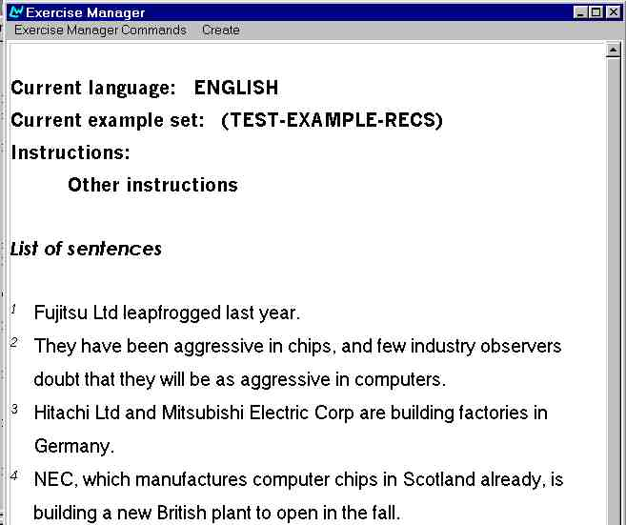
Figure 1. Exercise Manager. Main window.
Exercise Manager Commands brings out another menu with basic commands such as Load Examples and Clear Examples. These commands allow the user to load new sentences and to clear the sentences that are currently loaded.
Create brings out a menu with different options for the creation of activities from the loaded group of sentences. The options available right now are Shuffle words, Base forms and Hide words, as can be seen in figure 2:

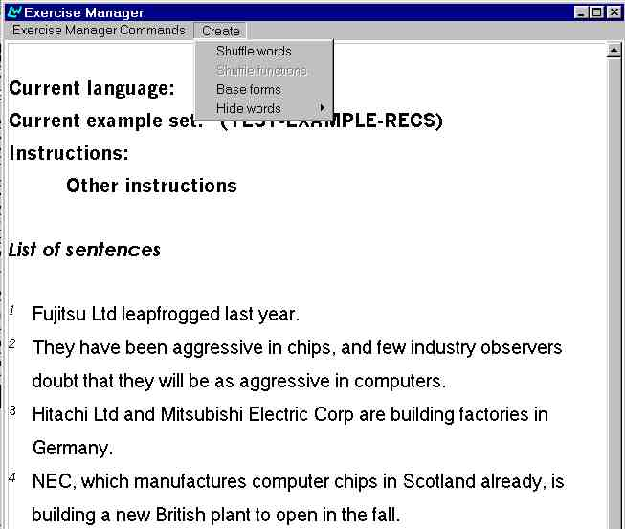
Figure 2. Commands for the creation of activities
The result of creating an activity by selecting Shuffle words can be seen in figure 3:

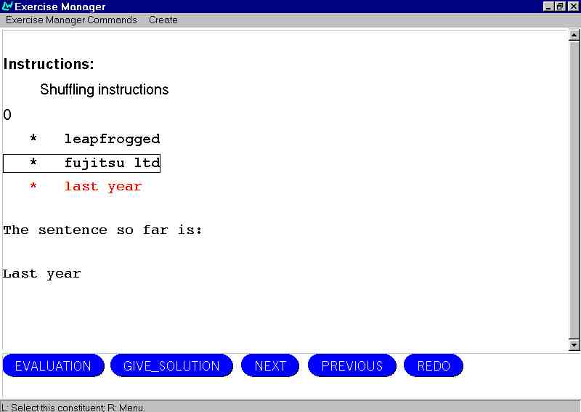
Figure 3. A shuffled sentence
Here the user must click on the different constituents to build a sentence with the correct word-order.
At the bottom of the screen are four buttons: Evaluation will examine the user’s answer and provide feedback; Give_solution simply gives the right solution to the sentence; Next moves to the next sentence in the exercise; Previous moves to the previous sentence in the exercise; Redo re-displays the sentence as it was initially presented before the users made any changes.
If we select Base forms instead of Shuffle words, the following menu pops up allowing us to choose what word-classes we want to remove. The program will then show the sentences leaving a gap where there was a word that has been removed. As a hint the user receives the base form of the missing word. It is possible to choose one or more word-classes for the same exercise, as figure 4 shows:

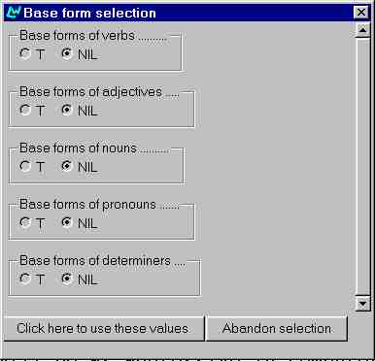

Figure 4. Sub-menu of Base forms exercise

Figure 5 shows the resulting activity after selecting Base form of verbs:

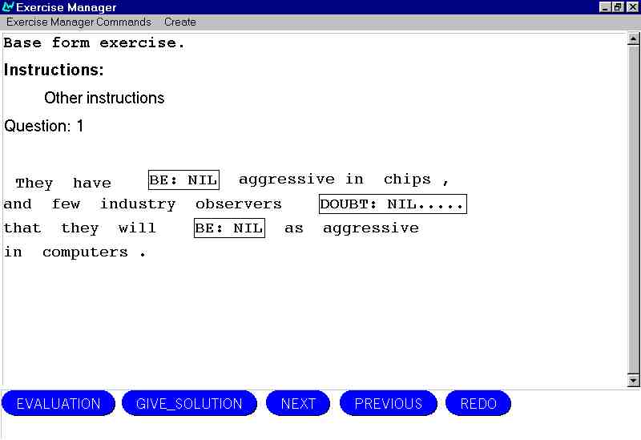
Figure 5. Activity obtained removing verbs and showing their base form
Finally, the command Hide words completely removes the word-classes selected without displaying the base form or any other hint. Figure 6 shows an activity obtained after removing the prepositions, this time using German sentences:

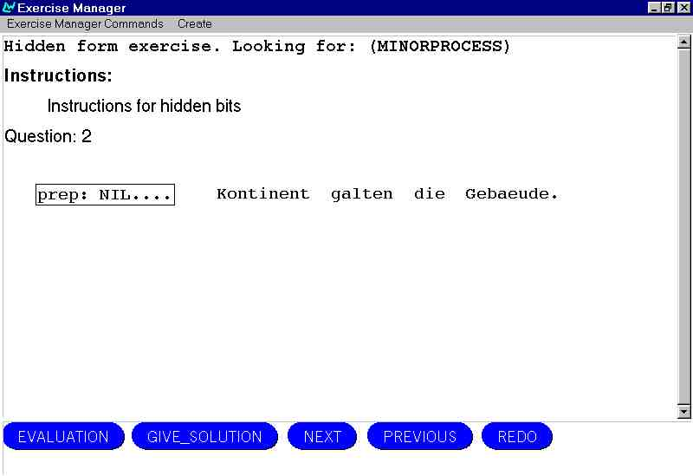
Figure 6. Activity for German obtained removing prepositions

Future work
The most immediate goal in the following 3 months will be the completion of the Exercise Manager and the refinement of the materials. The first round of tests with real students will take place in October, and it will be followed by a further refinement of the tool and the materials. A second round of tests will take place in November and December.
The subjects of the experiments will be selected from elementary and intermediate language classes for foreigners. The tests will consist of two phases: first the students will work on their own with the Exercise Manager and the materials prepared. This phase will be integrated in the normal course of the classes, and the activities performed with the program will serve as a follow-up to previous grammar explanations from the teacher. The main purpose of the first phase is to observe how students interact with the program interfering as little as possible, noting how many of the options available in the program are used by the subjects, which ones are used more frequently and what difficulties related with the use of the program are reported. The second phase will consist of personal interviews with the students after the session. The purpose of these is to exchange personal opinions about the program, such as what activities they preferred, if they found the corrections and comments made by the computer useful, what things they missed in the program, etc. The teacher will also be interviewed on these aspects.
The third year of the project will be devoted to two main tasks: the preparation of materials for tests with students of linguistics and the creation of a simple simulation that will reproduce a communicative context.
In the first case (students of linguistics) the experiments will also be part of the regular lessons and will serve as practice to theoretical explanations. The original KPML program will be used in the experiments, so no additional tool need be created for them. The subjects will be chosen from classes of linguistic studies, but since KPML contains a systemic-functional oriented grammar, they will be picked from courses that adopt this approach to language. The experiments will consist of the two phases mentioned above, although because of the problems that non-expert users might find in the use of KPML, they will receive more assistance and guidance in the first phase.
In the case of the simulation, the purpose of the experiments will be, just like in the case of the Exercise Manager, to prove that generators can interact with CALL programs saving time in the development of linguistic resources. For this it will be necessary to create a simulation that will be tested with students in the same way as I described above. The main difference will of course be the subjects: for this experiment it will be more convenient to choose students of upper-intermediate or advanced language courses. So far we have considered two ideas for the creation of the simulation: the first is a small universe with objects in which the student can ask questions about the position of the objects and give instructions to the computer to change them; the second is a universe in which different meteorological events take place and the student must give instructions depending on the events to help the computer attain a goal.
As I mention above in the report, the exploration of the possibilities generators offer in the area of writing skills will depend on the state of development of the Text Planner, a tool that builds texts using the resources of KPML.

REFERENCES
Allen, J. (1971) Two routines for use in CAI language programs. Computers and the Humanities. 6.2:125-128.
Biber et al. (1998) Corpus Linguistics. Investigating Language Structure in Use. Cambridge: Cambridge University Press.
Boylan, P. & Micarelli, A. (1998) Learning Languages as “Culture” with CALL. In Calvi, L., CALL, culture and the language curriculum. London: Springer.
Gavioli, L. (1997) Exploring Texts through the Concordancer: guiding the Learner. In Wichmann et al., Teaching and Language Corpora. London, New York: Longman.
Ghadessy et al. (2001) Small corpus studies and ELT: theory and practice. Amsterdam: Benjamins.
Higgins, J. And Johns, T. (1984) Computers in language learning. London: Collins ELT.
Hope et al. (1984) Using computers in teaching foreign languages. Orlando: Harcourt Brace Jovanovich.
Johns, T. (1997) Contexts: the Background, Development and Trialling of a Concordance-based CALL Program. . In Wichmann et al., Teaching and Language Corpora. London, New York: Longman.
Kenning, M.J. and Kenning, M.M. (1984) Introduction to computer assisted language teaching. Oxford: Oxford University Press.
Krieger, D. (2003) Corpus Linguistics: What It Is and How It Can Be Applied to Teaching. The Internet TESL Journal, Vol. IX, No. 3. http://iteslj.org/
Leech, G. (1997) Teaching and Language Corpora: a Convergence. In Wichmann et al., Teaching and Language Corpora. London, New York: Longman.
McCarthy (2002) Resisting Obsolescence in CALL. CALL-EJ Online, Vol.3, No.2. http://www.lerc.ritsumei.ac.jp/callej/
Maddalena, S. (2002) Corpus-based Computational Linguistics – A practical Investigation of the Precedures Involved in the Selection, Study and Exploitation of a Relevant Corpus. CALL-EJ Online. Vol. 3, No. 2. http://www.lerc.ritsumei.ac.jp/callej/
McEnery, T. (1996) Corpus linguistics. Edinburgh: Edinburgh University Press.
Pusack, J. (1983) Answer-processing and error correction in foreign language CAI. System 11.1:53-64.
Schmied, J. (1999) Applying Contrastive Corpora in modern contrastive grammars: The Chemnitz Internet Grammar of English. In Hasselgard and Oksenfjell eds. Out of Corpora. Studies in Honour for Stig Johansson. Amsterdam: Rodopi, 21-30.
Underwood, J. (1984) Linguistics, computers and the language teacher: a communicative approach. Rowley, Mass: Newbury House Publishers.
Wilson, E. (1997) The Automatic Generation of CALL Exercises from General Corpora. In Wichmann et al., Teaching and Language Corpora. London, New York: Longman.
Witton, N. (1992) Answer Analysis, Feedback and On-Line Reference Help in CALL with Particular Reference to German. In Pennington & Stevens Computers in applied linguistics: An international perspective. Clevedon, Englad: Multilingual Matters.

APPENDIX A

English courses:
Alexander, L.G. (1992) Longman English grammar practice for intermediate students. London: Longman.
Eastwood, J. (1987) A basic English grammar. Exercises with key. Oxford: OUP.
Kingsbury, R. & Wellman, G. (1985) Longman Advanced English. London: Longman.
Murphy, R. (2000a) Essential Grammar in Use. Cambridge: Cambridge University Press.
Murphy, R. (2000b) English Grammar in Use. Cambridge: Cambridge University Press.
O’Connell, S. (1991) Focus on First Certificate. London: Collins ELT.
Seidl, J. & Swan, M. (1986) Basic English usage: exercises with key. Oxford: OUP.
Soars, J. & and Soars, L. (1995) New Headway English course: intermediate. Oxford: OUP.
Soars, J. & and Soars, L. (1995) New Headway English course: upper-intermediate. Oxford: OUP.
Soars, J. & and Soars, L. (1998) New Headway English course: pre-intermediate. Oxford: OUP.
Willis, D. (1991) Collins Cobuild student’s grammar: practice material. London: HarperCollins.

Spanish courses:
Belchí Arévalo, M. (1998) Síntensis: curso intermedio de español. Madrid: Coloquio.
Borrego Nieto, J. (1991) Progresos: cursos intermedio de español. Salamanca: Universidad de Salamanca.
Equipo Avance, (1996) Antena: curso de español para extranjeros. Elemental. Madrid: SGEL.
Equipo Avance, (1996) Antena: curso de español para extranjeros. Intermedio. Madrid: SGEL.
Moreno García, C. (1997) Avance: curso de español. Madrid: SGEL.
Sánchez Lobato, J. (1997) Español sin fronteras. Madrid: SGEL.
Sánchez Lobato, J. (1999) Español 2000. Nivel elemental. Madrid: SGEL.
Sánchez Lobato, J. (1999) Español 2000. Nivel intermedio. Madrid: Sociedad General Española de Librería.

German courses:
Bock, H. et al. (1995) Themen Neu 2: Lehrwerk für Deutsch als Fremdsprache. Ismaning: Max Hueber Verlag.
Bock, H. et al. (1997) Themen Neu 1: Lehrwerk für Deutsch als Fremdsprache. Ismaning: Max Hueber Verlag.
Häussermann, U. et al. (1991) Sprachkurs Deutsch 1. Frankfurt a. M.: Diesterweg/Sauerländer.
Häussermann, U. et al. (1991) Sprachkurs Deutsch 2. Frankfurt a. M.: Diesterweg/Sauerländer.
Helbig, G. & Buscha, J. (2000) Übungsgrammatik Deutsch. Berlin: Langensheidt.
Hieber, W. (1984) Lehrziel Deutsch. Deutsch als Fremdsprache. Grundstufe 1. München: Max Hueber Verlag.
Hieber, W. (1985) Lehrziel Deutsch. Deutsch als Fremdsprache. Grundstufe 2. München: Max Hueber Verlag.
Luscher, R. (1998) Übungsgrammatik für Anfänger: Deutsch als Fremdsprache. Ismaning: Verlag für Deutsch, cop.

French courses:
Dominique, P. et al. (1988) Le noueveau sans frontières 1. Paris: Clé international.
Dominique, P. et al. (1990) Le noueveau sans frontières 2. Paris: Clé international.
Monnerie, A. (1990) Bienvenue en France. Méthode de français. Paris: Didier.

Russian courses:
Havronina, S. & Shirochenskaja, A. (1999) Russkij jazyk v uprazhnenjah. Moscow: Russky Yazyk Publishers.
Miller, L. V. et el. (1998) Zhili-Byli... 28 urokov russkogo jazyka dlja nachinajuschih. Ychebnik. Sanct Peterburg: Zlatoust.

Italian courses:
Katerinov, K. & Katerinov, M.C.B. (1985) La lingua italiana per stranieri. Perugia: Edizioni Guerra.
Chiuchiù, A. et al. (1990) In italiano. Perugia: Edizioni Guerra.

